Software Engineering

Assignment 2

Designing UML Diagrams

Bryan Yang

Table of Contents

UML case diagram for an in-home smart thermostat system 3

UML sequence diagram for the thermostat system 4

UML deployment diagram for the thermostat system 5

References: 6

## UML case diagram for an in-home smart thermostat system

Report that defines each type of diagram, explains their importance and use, and justifies the design decisions in your diagrams

The UML case use diagram used to depict how people in various roles (actors) can use the technology resource system. In this case, the in-house smart thermostat system (Gadagkar, 2020). This diagram is particularly useful to visualize the desired outcome of an interaction goal by mapping actor-system interaction depiction. I tried to use very basic design to make it as intuitive as possible for anyone looking at the diagram as my design philosophy (Gadagkar, 2020).

## UML sequence diagram for the thermostat system

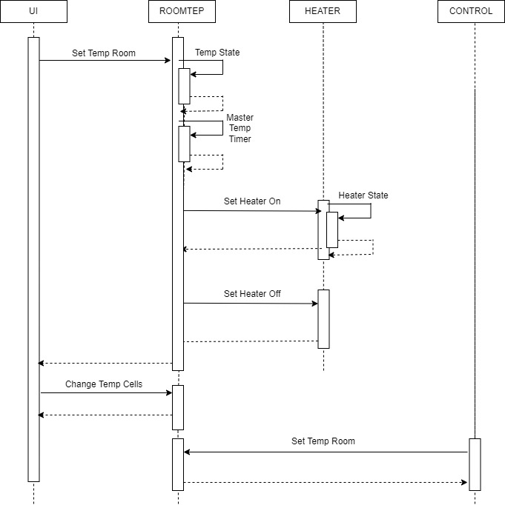

Report that defines each type of diagram, explains their importance and use, and justifies the design decisions in your diagrams

The sequence diagram shows the sequence of the messages passed and control structures between objects. This sequence diagram shows the temperature control of the smart thermostat system (Tuning, 2020). I designed to divde the sequences into four categories user interface, room temperature, heater, and control to understand the sequence of actions and relationships (Tuning, 2020).

## UML deployment diagram for the thermostat system

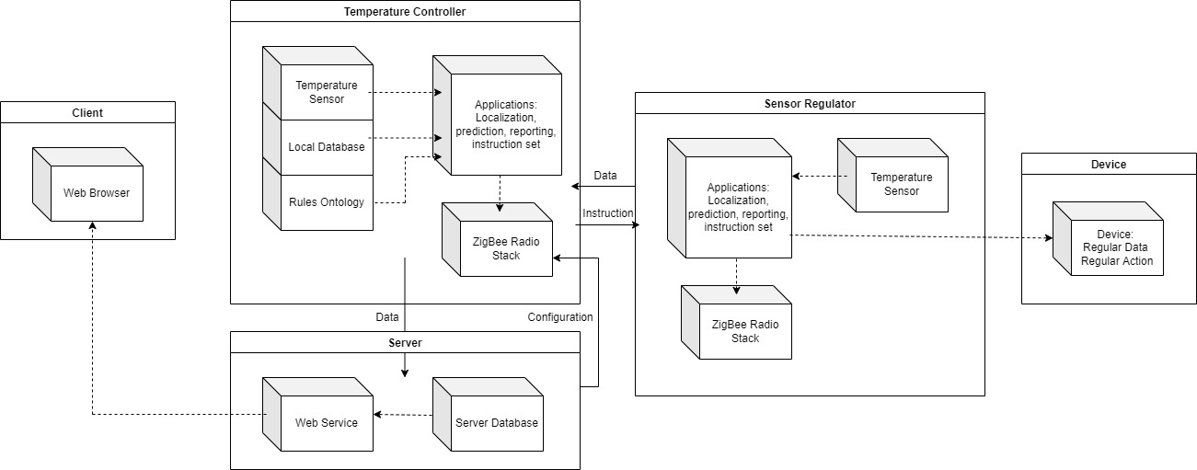

Report that defines each type of diagram, explains their importance and use, and justifies the design decisions in your diagrams

UML deployment diagram is useful for understanding the relationships between nodes (hardware), components (software), and the artifacts (products) (Tuning, 2020). It also shows dependencies of difference pieces based on the provided inputs of the interface system and between the existing nodes (stereotypes) (Tuning, 2020).

## References:

Gadagkar, S. (2020). *Study.com | Take Online Courses. Earn College Credit. Research Schools, Degrees & Careers*. Study.Com. https://study.com/academy/lesson/uml-models-design-examples.html

Tuning, S. (2020). *Study.com | Take Online Courses. Earn College Credit. Research Schools, Degrees & Careers*. Study.Com. https://study.com/academy/lesson/practical-application-for-software-engineering-uml-case-diagram.html

Tuning, S. (2020b). *Study.com | Take Online Courses. Earn College Credit. Research Schools, Degrees & Careers*. Study.Com. https://study.com/academy/lesson/practical-application-for-software-engineering-uml-deployment-diagram.html